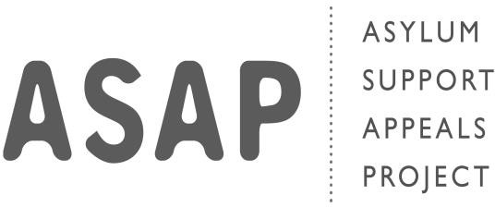

Complaints / Comments Form

Asylum Support Appeals Project (ASAP) aims to provide good quality ser- vice to all our service users. However, sometimes things can go wrong. If this happens, we would like to know what happened so that we can improve our services in the future and make things right.
If you are not happy about our service and would like to make a com- plaint, please complete this form and return it to the Director at the:
Asylum Support Appeals Project
Studios 11&12, Container City Building 48 Trinity Buoy Wharf
London E14 0FN
If you need help completing the form, or wish to make a complaint verbally, please contact the Director on 020 3716 0284 who will be happy to assist you.
Please also use this form to give us any comments you might have.
If you are making a complaint against the Director, please send the form to the Chair of the ASAP at the same address.

Your name
Telephone number
Address

In the box below, please describe the details of your com- plaint. It will be helpful if you can give as specific many de- tails as possible. You can also use the box below to give us any comments about ASAP.
Your complaint:

Continue to the next box

Your complaint (continued):

Please continue on to additional pages if you wish.

Date
Your signature

Asylum Support
Please send the completed form,
together with any additional pages, to:

ASAP Director or The Chair
Asylum Support Appeals Project

Studios 11&12, Container City Building 48 Trinity Buoy Wharf
London E14 0FN
Appeals Project (ASAP)

Company registered in England and Wales no. 04763838
Registered charity number 1105625

