

JOB INFORMATION PACK

Duty Scheme Legal Officer
(maternity cover)

About ASAP

The Asylum Support Appeals Project (ASAP) is a small national charity which was set up in 2003 to reduce the destitution of people seeking asylum by protecting their legal rights to food and shelter. We have a team of 12 permanent staff members and around 45 volunteer solicitors and barristers. We are based in East London but have a hybrid working model which allows remote working alongside a minimum amount of weekly time (2 days) spent in the office.

ASAP delivers three strands of work
- We offer free, high-quality legal representation at the Asylum Support Tribunal (AST) to people appealing against Home Office decisions to refuse or withdraw their support.
- We provide asylum support advice and training to hundreds of frontline organisations, advice agencies and legal practitioners working with people seeking asylum each year. We operate an advice line and online forum (Asylum Support Advice Network) for over 1000 members.
- We use our strong evidence base to improve policies and procedures on asylum support through closely linked policy work and strategic litigation.

Alongside this, we run a women’s project to ensure we offer a gender sensitive service to destitute women seeking asylum. We train women’s organisations in asylum support law, and undertake policy work for women seeking asylum, currently focused on access to support for people experiencing domestic abuse.

ASAP is recognised as a Centre of Excellence by the London Legal Support Trust.

Our vision
All people seeking asylum in the UK have shelter, food and support rather than living in destitution. The Home Office and AST are held to account, to ensure access to justice, dignity and equality for the people we serve.

Our key goals
Goal 1: Increase quality representation and dignity at the Asylum Support Tribunal for all people seeking asylum.
Goal 2. Ensure people seeking asylum across the UK have access to quality advice and information about their legal rights to food and shelter, by building other organisations’ asylum support skills.
Goal 3. Tackle the root causes of destitution through policy, influencing and litigation.
Goal 4. Maintain ASAP’s resilience, purpose and expertise, for people seeking asylum and the organisations supporting them.

You can find out more detail about our strategic plan here:
https://www.asaproject.org/uploads/ASAP_strategic_plan_2025_FINAL_16Oct2025..pdf

About the role
Post: Duty Scheme Legal Officer (maternity cover)

Responsible To: Acting Duty Scheme Co-ordinator (maternity cover)

Salary and benefits: £39,731 p.a. starting salary (including £4319 inner London weighting) plus 6% employer pension contribution, season ticket loan

Location: Hybrid working –2 days p/w in ASAP office, East London

Status: Fixed term contract (maternity cover) for approx 9 months, ideally starting in Jan 26. We will consider secondments.

Hours: 35 hours per week (excluding lunch break)

Leave: 30 days per annum plus bank holidays

This is a fixed term maternity cover role (anticipating approx. 9 months) supporting ASAP’s duty representation scheme at the Asylum Support Tribunal (AST) – one of our three key strands of work.
Working within our duty scheme team, you will assist our Acting Duty Scheme Co-ordinator and Duty Scheme Support Officer with key operational tasks, ensuring that the scheme is offering a quality service to appellants and referrers and that our duty scheme advocates (volunteer solicitors and barristers) are supported to provide high quality legal representation and advice.

After induction and training, you will give one-off guidance and support to people within the asylum support system who self-refer to ASAP, and to referring advice agencies, about the asylum support appeals process. You will also assist with decisions about which cases we represent. As with all team members, you will feed into our wider work on training, asylum support policy and strategic litigation – primarily by ensuring that colleagues are kept up to date with issues arising out of appeals at the Tribunal.

We’re looking for someone passionate about helping people seeking asylum in the UK access justice. You should be well-organised, a good team player, and have a solid understanding of the asylum support system—ideally from directly advising people who use it. In this role, you’ll develop your legal knowledge and skills by: observing hearings, reading appeal documents and legal decisions, attending training sessions and team meetings.

You’ll be joining a small, friendly, and supportive team that works closely together.
If you’d like to chat informally about the role, please contact: lilly@asaproject.org.uk

Closing date for applications by: Sunday 23 Nov at 11.59pm
Face to face interviews will be held in London on Weds 3rd Dec

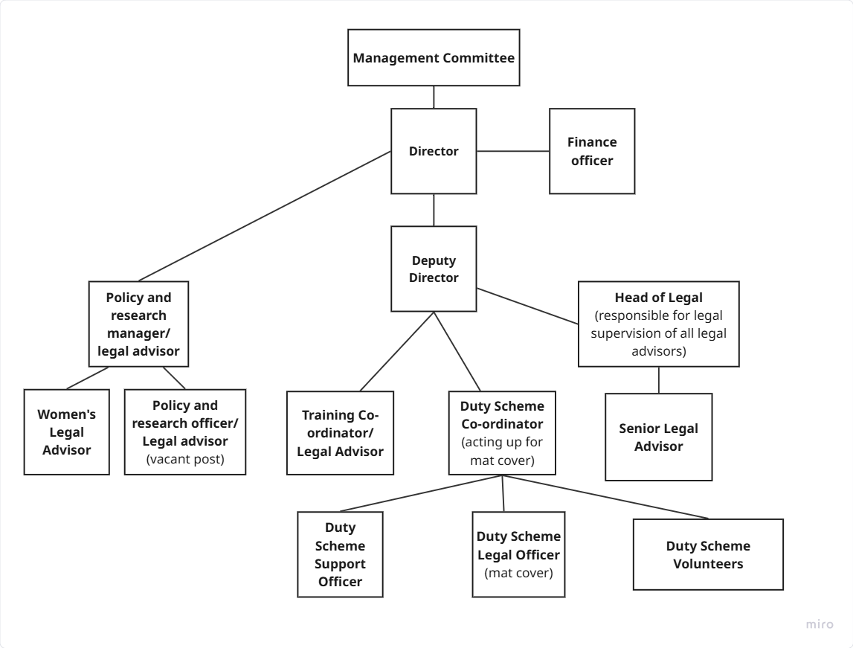
Job Description

Main duties and responsibilities:

Core operational tasks:

- Assist the Acting Duty Scheme Co-ordinator and Duty Scheme Support Officer with the day-to-day running of the duty scheme including (after induction/training):
- Lead on the weekly duty scheme planning cycle for upcoming appeals
- Assess which referrals will be represented when there are clashing cases and limited resources for representation
- Ensure that ASAP’s duty scheme monitoring systems are completed in a timely and accurate way

- Respond to queries from referring organisations, self-referring clients, the AST and the Home Office about upcoming hearings

- In coordination with the Acting Duty Scheme Co-ordinator, Head of Legal and other duty scheme team members, provide operational support to ASAP’s duty scheme advocates by, for example, ensuring that guidance documents are kept up to date and developed as needed

- Support the Acting Duty Scheme Co-ordinator and Head of Legal with administrative tasks related to the recruitment, training, induction and assessments of new duty scheme advocates as required.

- Be the primary source of cover for the Duty Scheme Support Officer and the Acting Duty Scheme Co-ordinator

Other

- Support ASAP’s policy work by contributing to information sharing within ASAP about specific hearings or general trends at the Tribunal, and by attending the Tribunal user-group meetings and ASAP stakeholder meetings where required

- Provide administrative support for any public ASAP events, i.e. conference, if one happens during the period of the post

General

- Ensure that all handling of client information is done with respect for client confidentiality and in line with ASAP’s data protection policies.

- Attend regular line management support and supervision sessions with the Acting Duty Scheme Co-ordinator and professional development training as required
- Attend and actively participate in team meetings and ASAP events

- Ensure that all work carried out will be in the best interests of asylum-seekers and refugees and in accordance with the Diversity, Equity and Inclusion Policy

- Uphold the ethos and protect the good name of ASAP, working in line with ASAP policies and procedures

Person Specification
 | Essential unless indicated as desirable
Commitment to people in the asylum system and insight into their experiences | - Understanding of the experiences of people seeking asylum in the UK and commitment to upholding their legal rights and entitlements  - Lived experience of the UK asylum system (desirable)  - Experience of working with people seeking asylum in a legal advice context (desirable)
Asylum support law/ legal skills | - Minimum 2 years’ full-time or part-time equivalent experience of advice work within a voluntary sector or legal organisation (this can include giving advice on asylum support eligibility)  - Knowledge of asylum support law and asylum support appeals, and/or related areas (e.g. housing/ welfare benefits/ immigration law/ community care)  - Ability to grasp legal concepts quickly and apply them to individual cases
Administrative, organisational and team-working skills | - Excellent organisational and administrative skills in a pressured environment, including a high level of attention to detail  - Demonstrable ability to work in a small team in a cooperative, flexible and supportive manner  - Experience of effectively communicating by email and over the phone with a range of audiences/ stakeholders  - Good working knowledge of Microsoft 365, including Excel  - Understanding, awareness of and commitment to the principles and practice of equal opportunities and diversity
A pre-existing right to work in the UK is required.

Application Process

ASAP is an equal opportunities employer. We welcome applications from individuals regardless of age, disability, gender, gender reassignment, marital status, pregnancy/maternity, race, religion and belief, sex or sexual orientation. We positively encourage applicants with lived experience of seeking asylum and/or asylum support.

If you are an expert by experience (a refugee or a migrant with direct, first-hand experience of issues and challenges of the UK asylum or immigration system), you can ask for independent and confidential support for your job application from the Experts by Experience Employment Network (www.ebeemployment.org.uk). Please complete the form on their website to request support and they will confirm if they can match you with a mentor to support your application.

To apply, please complete the application form and equality and diversity monitoring form (see links on website) and send them to Lilly Barritt: lilly@asaproject.org.uk . Please quote “Job Ref: ASAP Duty Scheme Legal Officer CONFIDENTIAL.” in the subject of your email.

We are looking for someone who has a good level of written English and the ability to understand and communicate complex legal issues without the use of AI. For this reason, we encourage people not to use AI when applying for the role. Applications with very high indicators of AI-generated content may score lower, particularly where responses lack originality or personal insight.

Face to face interviews will take place at our office in London and will consist of a practical test of your abilities relating to the role and a standard interview with a panel of three people. Please let us know in advance of your interview if you have a disability and require reasonable adjustments for the interview and/or assessment process to ensure the process is fair and equitable to all applicants.

We will consider requests to attend the interview remotely, but our strong preference is for people to attend in person.

ASAP keeps assessment records/notes for all applicants, whether shortlisted or not, for 12 months. They are stored securely and then destroyed securely after the above period. All short-listed candidates will be notified of their selection decision and can obtain feedback from the assessment if they request it.

Closing date for applications: Sunday 23 Nov at 11.59pm

Face to face interviews will be held in London on Weds 3rd Dec

