JOB INFORMATION PACK

POLICY AND RESEARCH OFFICER / LEGAL ADVISOR

June 2026

About ASAP

The Asylum Support Appeals Project (ASAP) is a small national charity which was set up in 2003 to reduce the destitution of people seeking asylum by protecting their legal rights to food and shelter. We have a team of 13 permanent staff members and around 35 volunteer solicitors and barristers. We are based in East London but have a hybrid working model which allows remote working alongside a minimum amount of weekly time (2 days) spent in the office.

ASAP delivers three strands of work
- We offer free, high-quality legal representation at the Asylum Support Tribunal (AST) to people appealing against Home Office decisions to refuse or withdraw their support.
- We provide asylum support advice and training to hundreds of frontline organisations, advice agencies and legal practitioners working with people seeking asylum each year. We operate an advice line and online forum: the Asylum Support Advice Network (ASAN) for over 1400 members.
- We use our strong evidence base to improve policies and procedures on asylum support through closely linked policy work and strategic litigation.

Alongside this, we run a women’s project to ensure we offer a gender sensitive service to destitute women seeking asylum. We train women’s organisations in asylum support law, and undertake policy work for women seeking asylum, currently focused on access to support for people experiencing domestic abuse.

ASAP is recognised as a Centre of Excellence by the London Legal Support Trust and is AQS accredited.

Our vision
All people seeking asylum in the UK have shelter, food and support rather than living in destitution. The Home Office and AST are held to account, to ensure access to justice, dignity and equity.

Our key goals
Goal 1: Increase quality representation and dignity at the AST for all people seeking asylum.
Goal 2. Ensure people seeking asylum across the UK have access to quality advice and information about their legal rights to food and shelter, by building other organisations’ asylum support skills.
Goal 3. Tackle the root causes of destitution through policy, influencing and litigation.
Goal 4. Maintain ASAP’s resilience, purpose and expertise, for people seeking asylum and the organisations supporting them.
You can find out more detail about our strategic plan here: https://www.asaproject.org/uploads/ASAP_strategic_plan_2025_FINAL_16Oct2025..pdf

ASAP Organogram

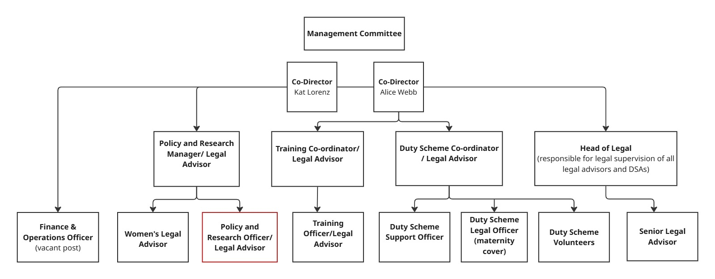
About the role

Post: Policy and Research Officer/Legal Advisor
Responsible To: Policy and Research Manager (quality of legal advice overseen by Head of Legal)
Salary and benefits: £42,539 p.a (including £4319 inner London weighting)
6% employer pension contribution (2% employee)
Annual salary increases up to top of the band (NJC points 27-30)
Potential cost of living increases each year
Season ticket loan
Study loan
Enhanced maternity/partner/adoption pay
Up to 5 days paid special leave per year for unexpected
dependant care
Employee Assistance Programme, access to
counselling
Flexible working (around core hours 10am-4pm)
Location: Hybrid working –minimum 2 days p/w in ASAP office, East London (including an ‘anchor day’, currently Thursdays)
Status: Permanent contract after a 4-month probation period
Hours: 35 hours per week (excluding lunch break)
Leave: 30 days per annum pro rata plus bank holidays

This exciting role covers both legal and policy work with real scope to develop professional skills and make a tangible impact. It would suit someone who is legally and analytically minded, who is also interested in reducing destitution by influencing Home Office policy and practice.

ASAP’s policy work emerges from evidence gathered from our appeals work and our Advice Line, ASAN and training work. We focus on the quality of Home Office decisions on asylum support, including whether they are lawful, as well as access to justice through the appeals system. As such, our policy work always has a legal slant. We carry out our policy work through discussions with officials, and where necessary parliamentary work and strategic litigation.

The role includes:

- Legal Advice - The post-holder will represent destitute people seeking asylum at the AST as well as offering advice to other advisers via ASAP’s second-tier Advice Line.
- Policy and Research - Working closely with colleagues, the post-holder will:
  - Look for emerging trends emanating from ASAP’s legal work to support the development of external policy positions;
  - Alongside colleagues in the policy team, undertake in-depth research based on this analysis;
  - Assist the Policy and Research Manager to engage with the Home Office, the AST and other stakeholders to influence improvements to policy and practice.
- Monitoring: the post-holder is responsible for collating and analysing operational data from our appeals and Advice Line work. This is used to inform policy and operational decisions. They will also assist the Policy and Research Manager with the transition to a new database which we are in the process of acquiring.
You will:
- Have strong communication skills, with the ability to explain legal concepts clearly and confidently to a range of audiences.
- Be legally minded, with a strong interest in the law and how it can be used to challenge injustice and uphold rights.
- Have an aptitude for interpreting data and presenting information in an accessible way.
- Have a good understanding of the asylum support system — ideally gained through direct advice work or closely related experience.
- Be a collaborative team player who enjoys working closely with others in a small, supportive team.
You do not need to be legally qualified, but you do need enthusiasm for legal work and a commitment to using the law as a tool for positive change.
You’ll be joining a small, friendly and supportive organisation where colleagues work closely together and value learning, collaboration and mutual support.
If you’d like to have an informal conversation about the role, please contact marie-anne@asaproject.org.uk
Closing date for applications by: midnight on Sunday 5th July

Face to face interviews will be held in London on Thursday 16th July

JOB DESCRIPTION

- Legal advice
- Following a legal induction and with ongoing support:
  - Provide legal advice and representation to destitute people seeking asylum at the AST.
  - Provide legal advice on asylum support and asylum support appeals to advice workers, refugee agencies and legal practitioners via ASAP’s Advice Line.
- Where requested, take part in reciprocal peer and file reviews to maintain quality of legal advocacy, advice and file management.

- Research and policy

- Analyse ASAP’s data to identify patterns of unlawful or concerning practices by the Home Office and other key stakeholders in the asylum support system, feeding into ASAP’s policy strategy.
- In Liaison with the Policy and Research Manager, use this trend analysis to carry out research and produce reports, presenting findings to internal and external stakeholders where appropriate.
- Support the Head of Legal with strategic litigation work that sometimes flows from this research.
- In liaison with the Policy and Research Manager and Training Co-ordinator, provide updates to sector colleagues on asylum support policy developments through email, published materials, or participation in external meetings, including ASAN meetings.
- Where appropriate, deputise for the Policy and Research Manager in external meetings.
- Service monitoring and data analysis

- Carry out monthly monitoring of ASAP’s appeals and Advice Line work and produce statistical reports when required.
- Develop and maintain the necessary administrative systems to support ASAP’s service monitoring and research functions.
- Support the Policy and Research Manager with the transition to a new database.
- Other
- Ensure that all handling of client information is done with respect for client confidentiality and in line with ASAP’s data protection policies.
- Attend regular support and supervision sessions with the Policy and Research Manager, and professional development training as required.
- Attend regular legal supervision sessions with the Head of Legal.
- Attend and actively participate in team meetings and ASAP events.
- Attend external stakeholder meetings as required.
- Ensure that all work carried out is in the best interest of people in the asylum system and in accordance with ASAP’s Equity, Diversity and Inclusion Policy.
- Uphold the ethos and protect the good name of ASAP, working in line with ASAP policies and procedures at all times.

PERSON SPECIFICATION

 | Experience/Knowledge/Skills (essential unless indicated otherwise)
General | A pre-existing right to work in the UK is required
Commitment to working with people seeking asylum | A commitment to asylum/ human rights/ social justice issues  Understanding of the issues affecting asylum-seekers in the UK particularly in relation to asylum support  Understanding, awareness of and commitment to the principles and practice of equal opportunities and diversity
Legal | Minimum 2 years’ full time (or part time equivalent) experience of legal advice work within a voluntary or legal organisation (this can include giving advice on asylum support eligibility)  Knowledge of asylum support law and asylum support appeals, and/or related areas (eg housing/ welfare benefits/ immigration law/ community care)  Ability to carry out legal research and keep up to date with legal and policy developments  Ability to grasp legal concepts quickly and apply them to individual cases  Ability to provide legal representation at the AST after 4 months in post  Experience of providing legal representation (written and oral) in Tribunals or courts (desirable)  Legal qualification or equivalent experience (desirable)
Research, policy and monitoring | Ability to gather and analyse numerical data and user feedback  Excellent English written and verbal skills with the ability to communicate with a wide range of audiences  Track record of developing relationships with other organisations or professionals  Experience of using databases, using Excel and setting up monitoring systems (desirable)  Experience of carrying out qualitative and quantitative research and presenting findings in a written and verbal format (desirable)  Track record of representing an organisation externally (desirable)
Other | Demonstrable ability to work in a small team in a cooperative, flexible and supportive manner.  Demonstrable ability to manage own time by prioritising tasks and meeting competing deadlines without continuous supervision.  Working knowledge of Microsoft 365 (desirable)

Application Process

ASAP is an equal opportunities employer. We welcome applications from individuals regardless of age, disability, gender, gender reassignment, marital status, pregnancy/maternity, race, religion and belief, sex or sexual orientation. We positively encourage applicants with lived experience of seeking asylum and/or asylum support.

We are part of the Experts by Experience Employment Initiative (www.ebeemployment.org.uk). The network supports inclusive recruitment of people with lived experience of the UK asylum or immigration system. If this is your experience, you can find useful resources here. You can also ask for free and private help with your application by filling in this form.

To apply, please complete the application form and equality and diversity monitoring form (see links on website) and send them to Marie-Anne Fishwick: marie-anne@asaproject.org.uk. Please quote “Job Ref: ASAP Policy and Research Officer CONFIDENTIAL.” in the subject of your email. Please make sure you refer to examples of your experience/abilities, when explaining how you meet the person specification.

We are sorry that we are unable to provide feedback to people who are not short-listed for interview. If you have not received an email from us inviting you to interview by 10th July 2026, please assume you have not been short-listed.

We are looking for someone who has a good level of written English and the ability to understand and communicate complex legal issues without the use of AI. For this reason, we encourage applicants to complete their supporting statement in their own words as far as possible. This is important as the supporting statement is a key opportunity for you to demonstrate your personal insight, individual skills, experience and writing style.

Face to face interviews will take place at our office in London and will consist of a practical test of your abilities relating to the role and a standard interview with a panel of three people. Please let us know in advance of your interview if you have a disability and require reasonable adjustments for the interview and/or assessment process to ensure the process is fair and equitable to all applicants.

We will consider requests to attend the interview remotely, but our strong preference is for people to attend in person.

ASAP keeps assessment records/notes for all applicants, whether shortlisted or not, for 12 months. They are stored securely and then destroyed after the above period.

All short-listed candidates will be notified of the selection decision and can obtain feedback about their interview if they request it.

Closing date for applications: midnight on Sunday 5th June 2026

Face to face interviews will be held in London on Thursday 16th July 2026

